**GIT URL :**

Project Name : **Grocers-Application**

Technologies use : **Core Java, Spring MVC,Maven HTML,CSS,JSP, bootstrap and JPA**.

Spring and JPA dependencies added through Maven tool

Web Server : tomcat 9

Database : MySQL

Tables script file present in the project folder only with name as grocers_db.sql

Check in dispatcher-servlet.xml file

<bean id=*"ds"* class=*"org.springframework.jdbc.datasource.DriverManagerDataSource"*>

<property name=*"driverClassName"* value=*"com.mysql.cj.jdbc.Driver"*></property>

<property name=*"url"* value=*"jdbc:mysql://localhost:3306/mydb?useSSL=false"*></property>

<property name=*"username"* value=*"root"*></property>

<property name=*"password"* value=*"root@123"*></property>

</bean>

URL : grocers

userName : root

password :root@123

**Screen shot of the application**

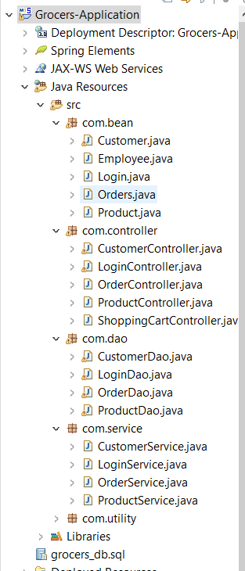

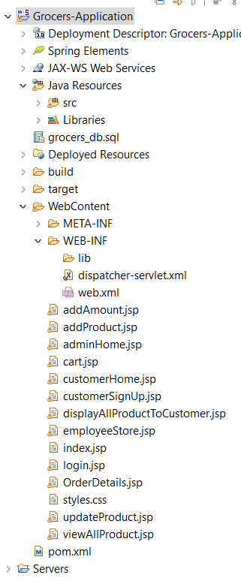

Screen shot of the application

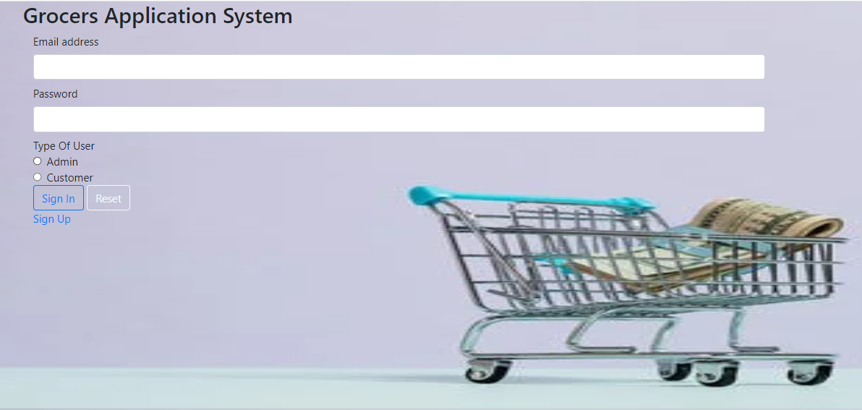

Admin user Name is : [admin@gmail.com](mailto:admin@gmail.com)

Password is : admin

Admin dashboard

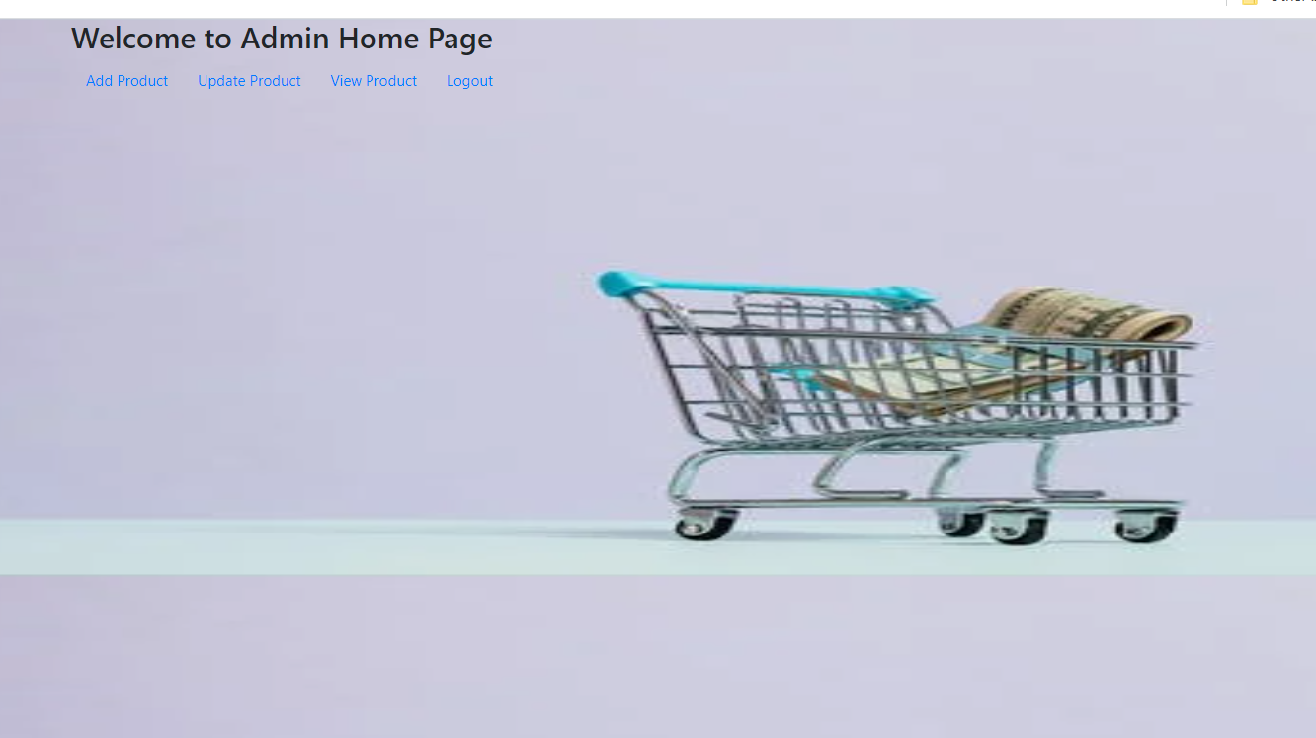

View Projects

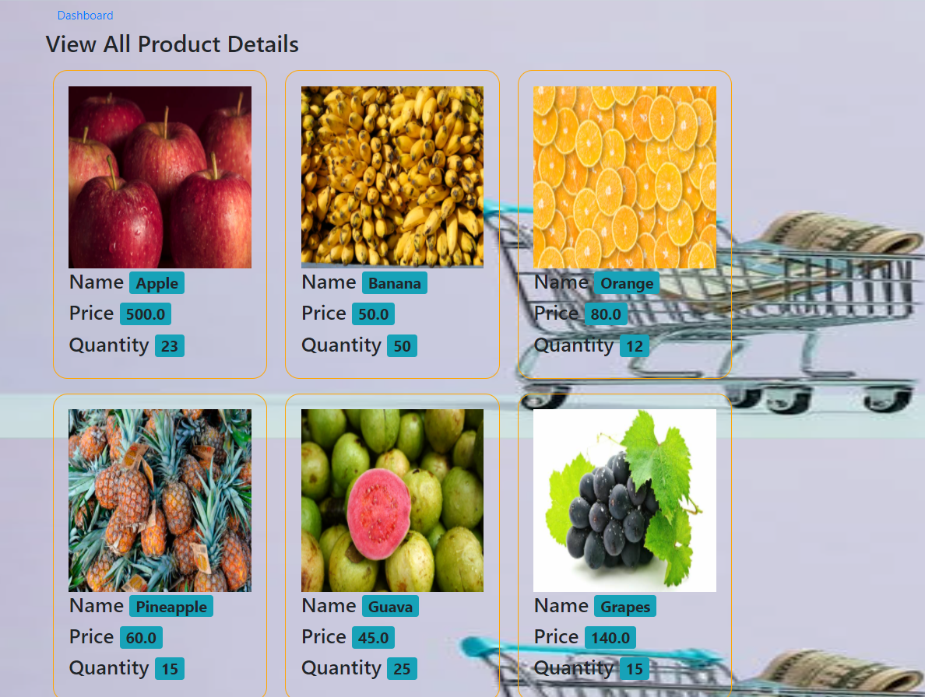

Add grocers items

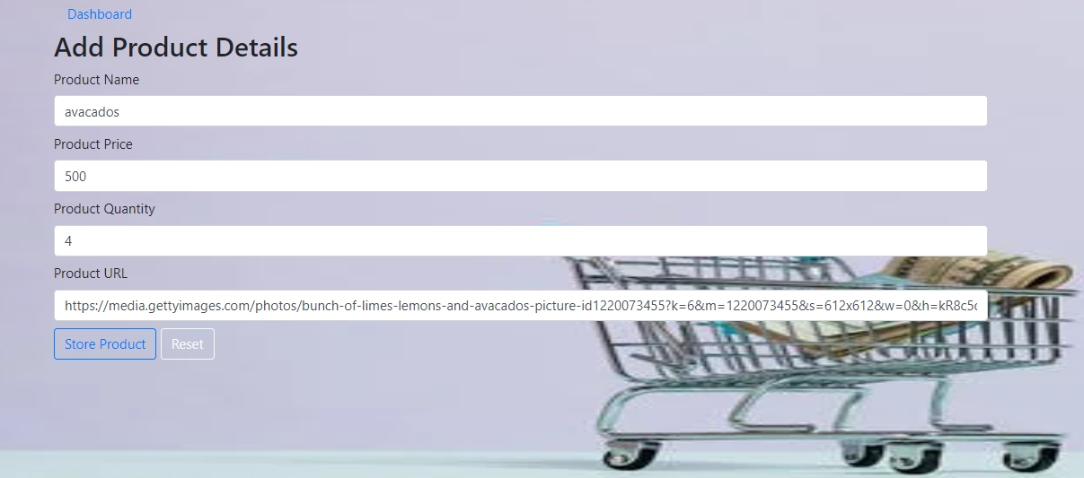

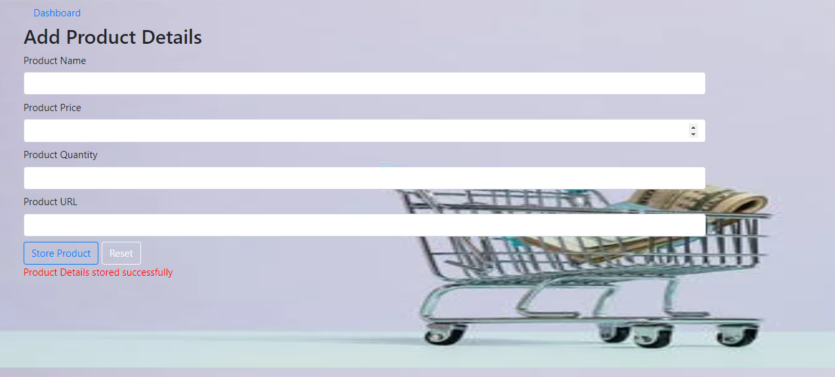

Search product

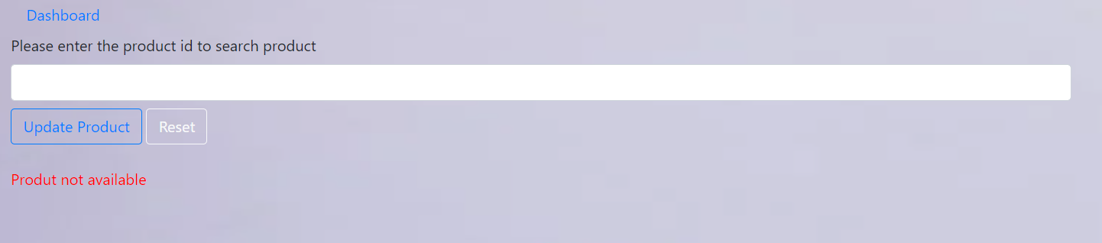

Update the product price and quantity

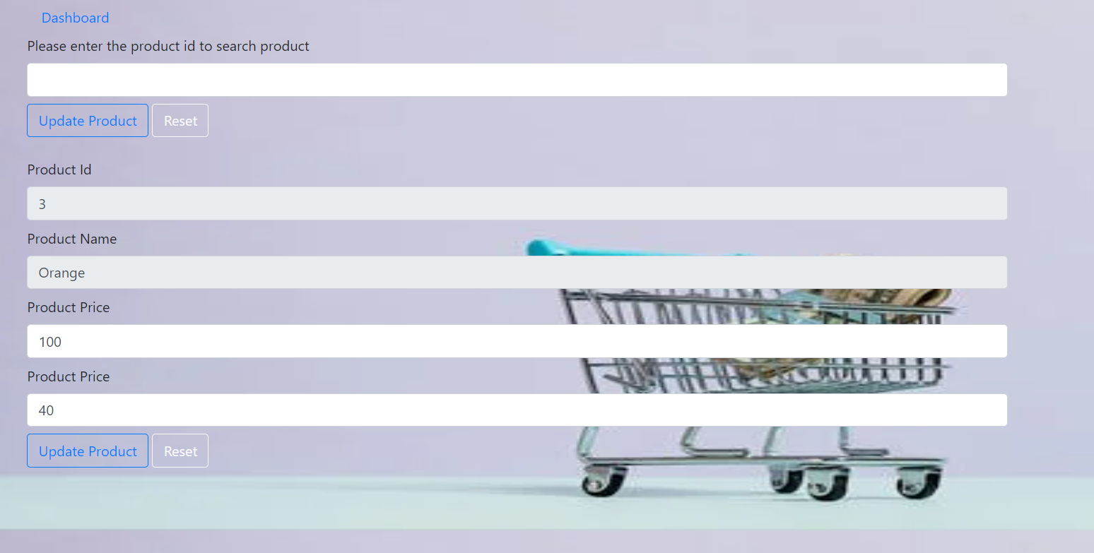

Customer SingUp

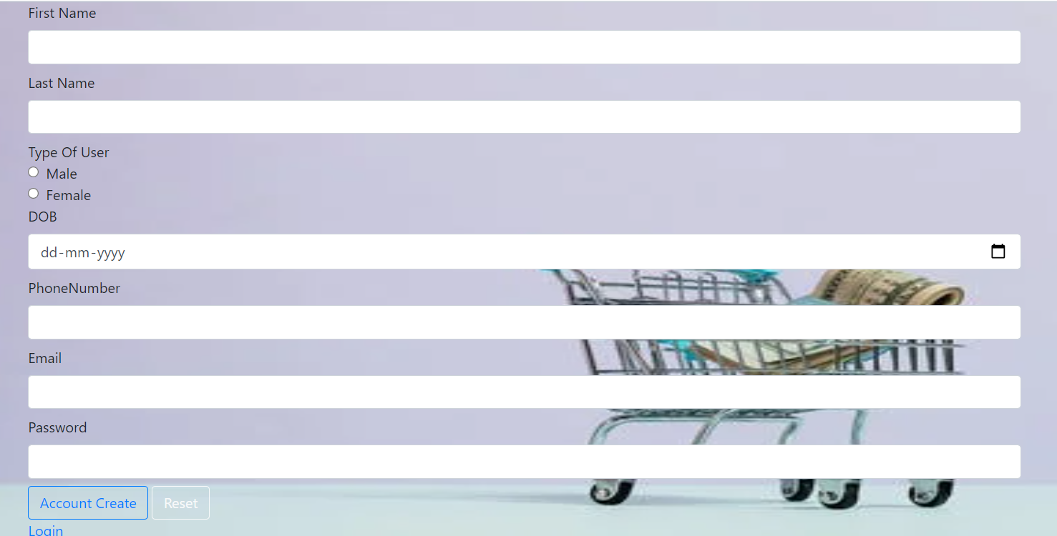

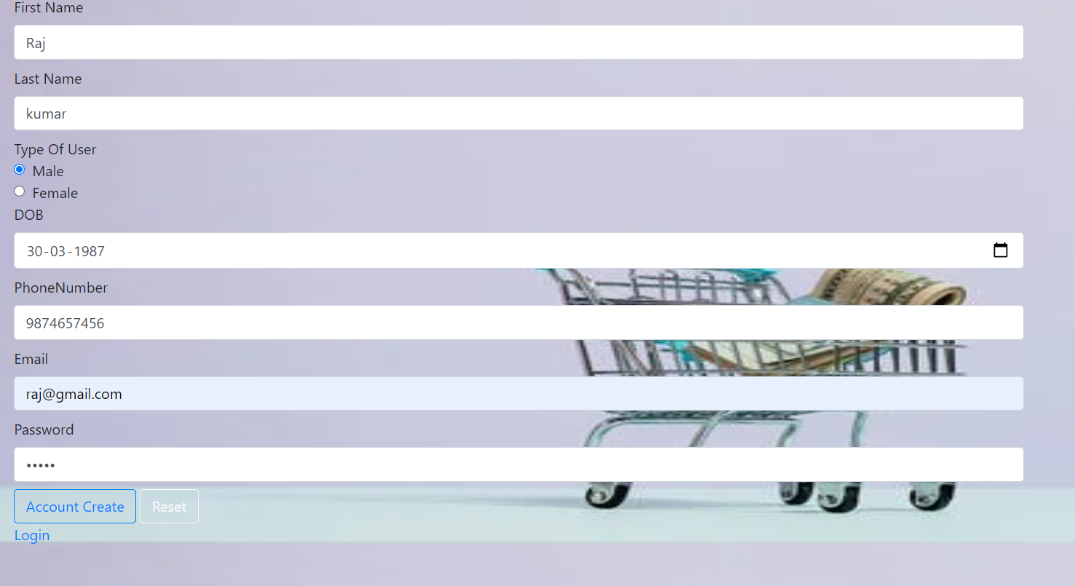

Customer dashboard



Customer shopping page

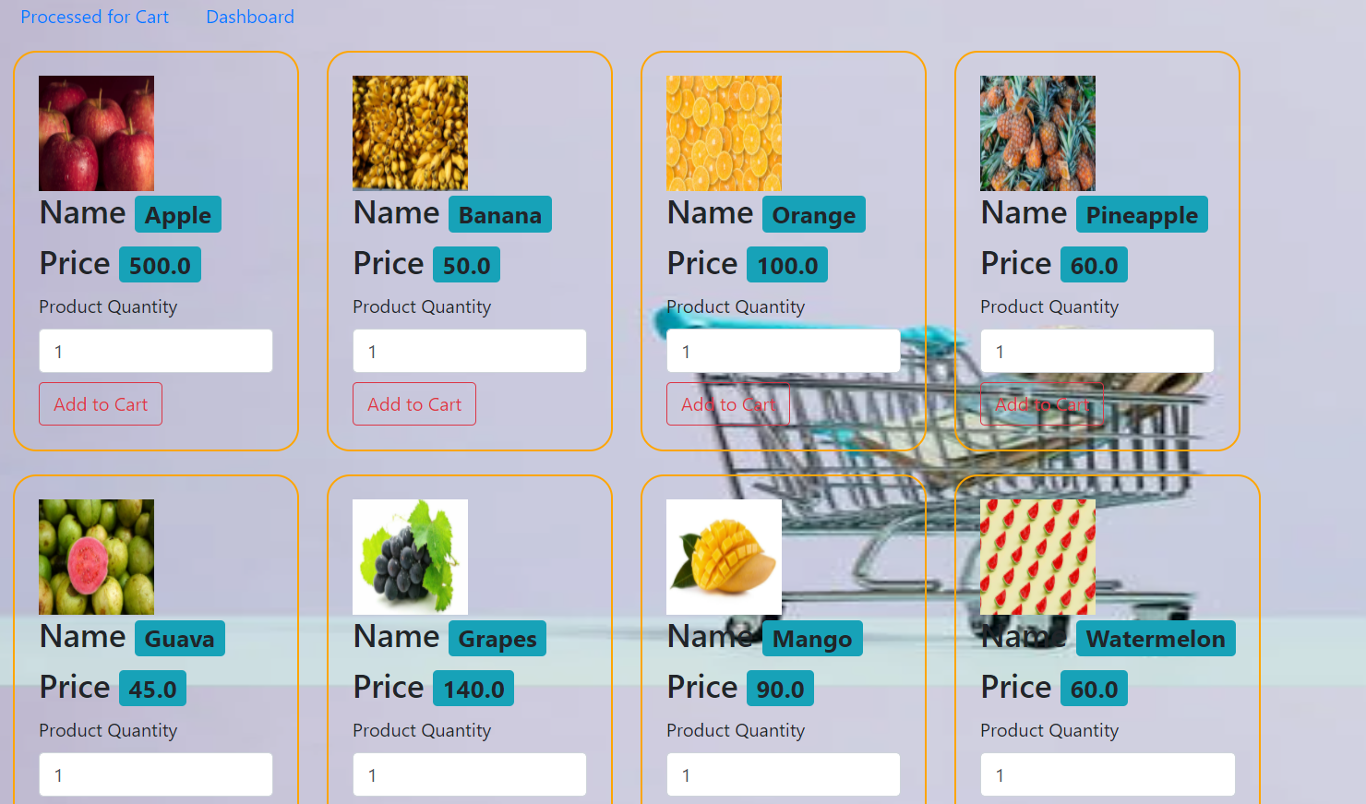

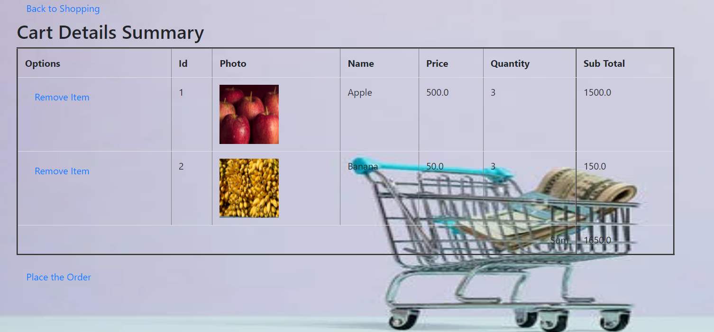

Amount Details

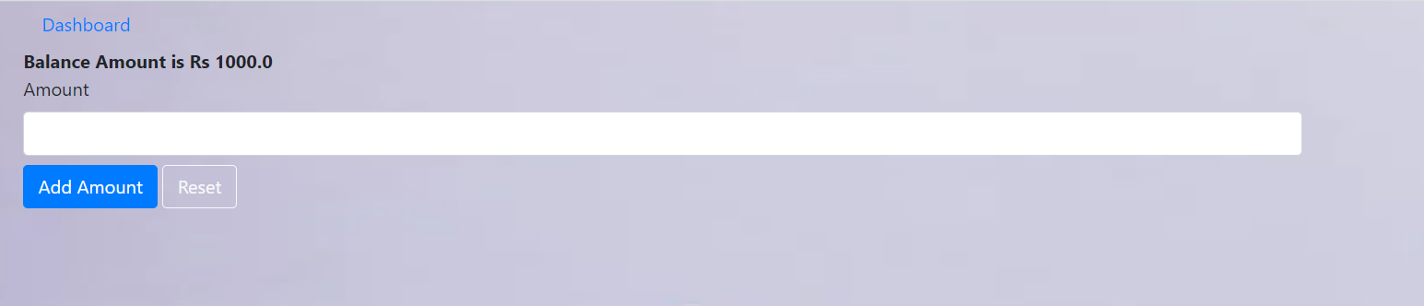

Amount added

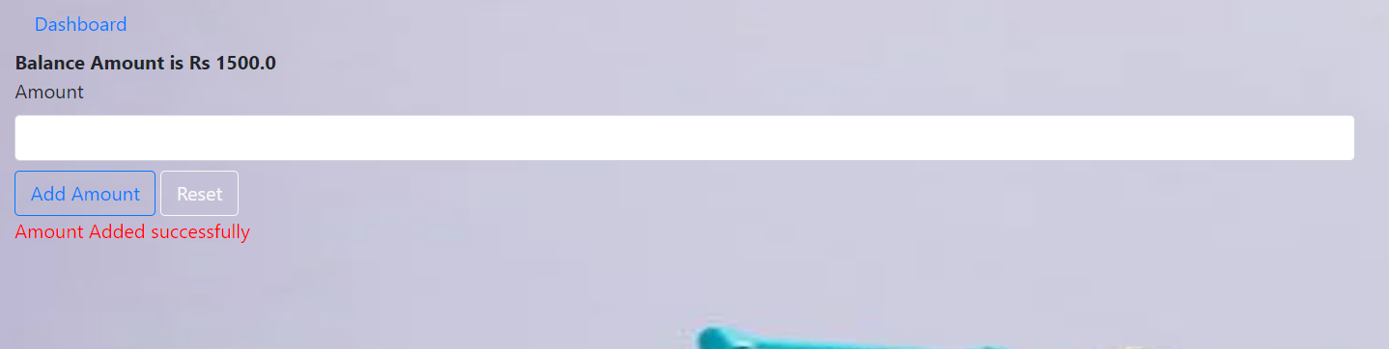

Order Details

